Folding hoods can obscure the best part of the garment and what customers need to see: the hood itself! Feature this fold on the top of a stack of folded hoods. Stacks should be a maximum of about 4 hoods. It may not be necessary to do this on every stack on the fixture. Alternate this fold with traditional folded stacks for greater texture and impact.

1. Place Hood Face down. Fold each in horizontally.
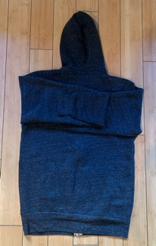
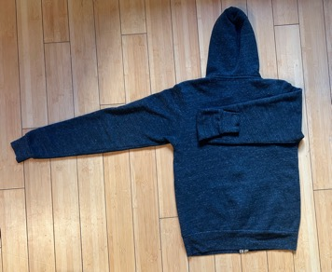
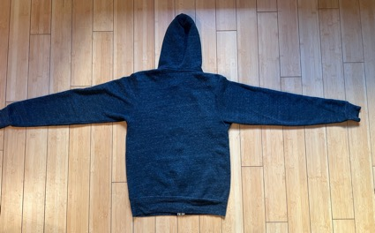

3. Flip garment placing hood underneath. Straighten the string-ties and pull the hood up around the body of the garment.
2. Fold each side into Center Back. Fold waist to meet shoulders.

F

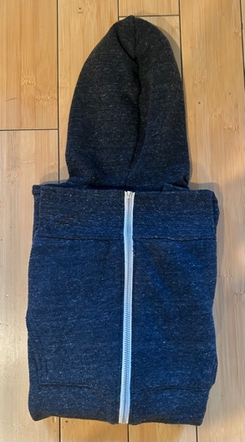
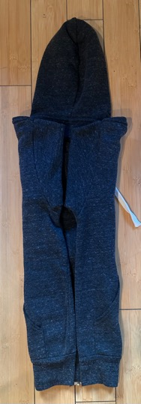

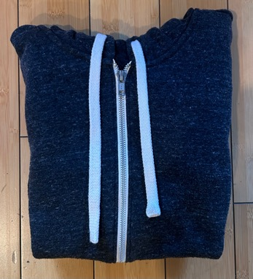
V 1.0 February 2025

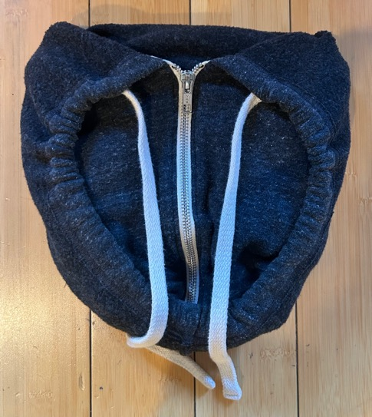
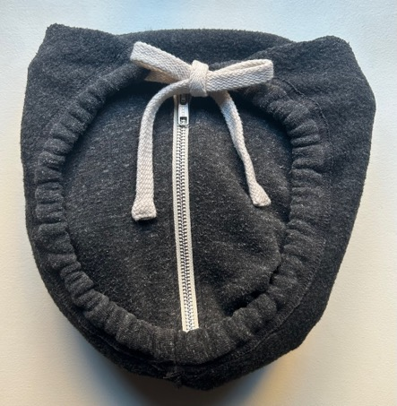
V 1.0 February 2025
*Pictured here is a mix of the Hood Fold with traditional folded hoods.
4. The body will nest inside the hood. Gently tug the string-ties and tie a bow or slip knot.
5. Place completed hoods on top of the corresponding stacks.

