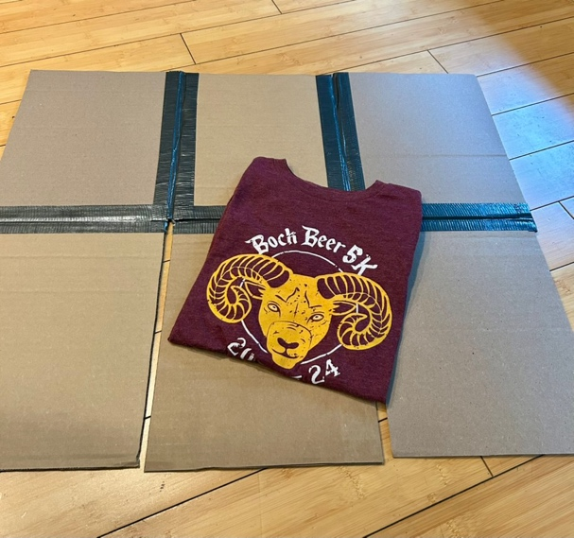
Build Your Own Board
Step 1: Cut six identically sized pieces of cardboard that match the finished fold garment specs.
Step 2: Lay cardboard out 3x2 as shown left. Important! Make sure there is at least 1/4” to 3/8” between each piece.
Step 3: Use Duct Tape to affix cardboard together on both sides.
Step 4: See red arrow below. Cut to remove excess tape from the taped intersections.

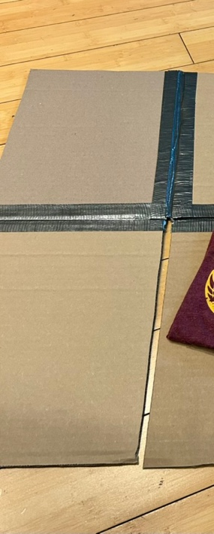

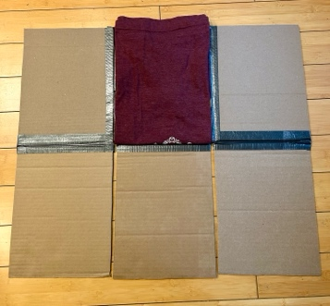
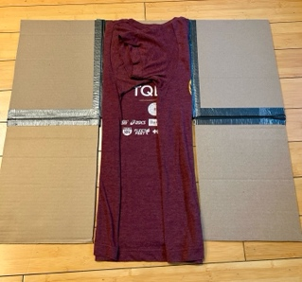
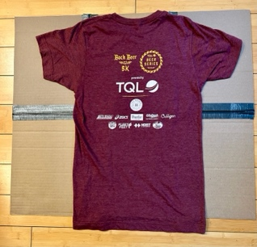
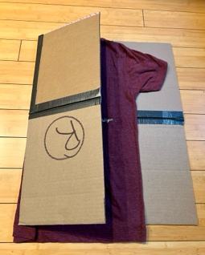
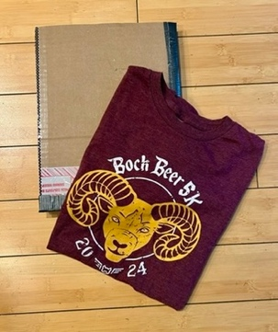
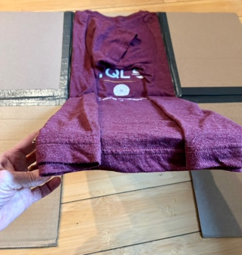
Once assembled, use as below:
You’ll Need Sturdy Cardboard, a Ruler, a Utility Knife/Box Cutter, and Duct tape
- Duct Tape
Pro Tips
First, measure a folded shirt. Cut cardboard to fit your sample.
Or
Measure a fixture, such as a cube fixture, before you cut. Cut cardboard to fit your sample.
v 1.0 February 2025
Gently lift center panel upwards to complete the fold.
Place garments in stock.
Remove folded garment.
Fold each side to the center.
Place Garment face-down.
Place hands under center panel.

